Web & Mobile Programming ICP13

ICP7 Group 26

Name: Nelakuditi Meghana Chowdary

Email:mn6f7@umsystem.edu

source code link: <https://github.com/UMKC-APL-WebMobileProgramming/ICP13-MeghanaNelakuditi/tree/main/ICP13(mobile)/Source/MedicalAssistant>

Video link:

<https://drive.google.com/file/d/1OudIOv5PGAqgcucDgty2kssf16jOEE4e/view?usp=sharing>

My Partner:

Name: Madhavilatha Damecharla

Email: [mdcm2@umsystem.edu](mailto:mdcm2@umsystem.edu)

Source code link:

<https://github.com/UMKC-APL-WebMobileProgramming/ICP12-mdcm2/tree/main/Source>

This ICP is all about performing

1.Use the layout given in the second use case speech to text.

2.As soon as the app opens,it should say hello

3.Then the user clicks on the mic button to say hello

4.Once the user said hello,the app should speak,"what is your name?"

5.Then the user clicks on the mic button to say, "My name is"+<your name>

6.Extract the name of the user and then save it as editor level.Code snippet: private SharedPreferences preferences;private SharedPreferences.Editor editor;preferences = getSharedPreferences(PREFS,0);editor = preferences.edit();editor.putString(NAME,<extracted name>).apply();//private static final String NAME = "name";

7.Also,show the name on the screen 8.When the user asks the following questions, appropriate answers should be given: Implement any threeof these:QuestionAnswerI am not feeling well. What should I do?I can understand. Please tell your symptoms in short.

The below code is for saying hello

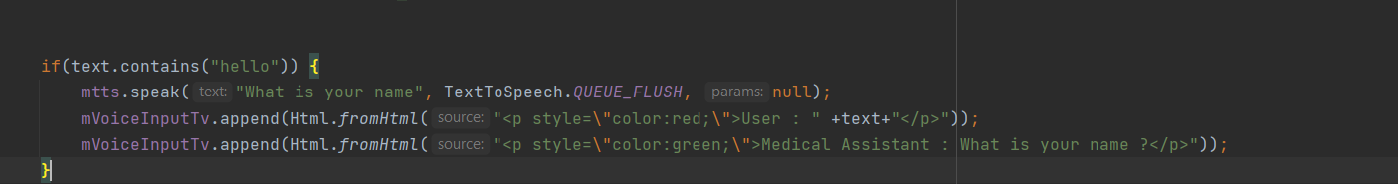

The below code is for the asking name and displaying the name

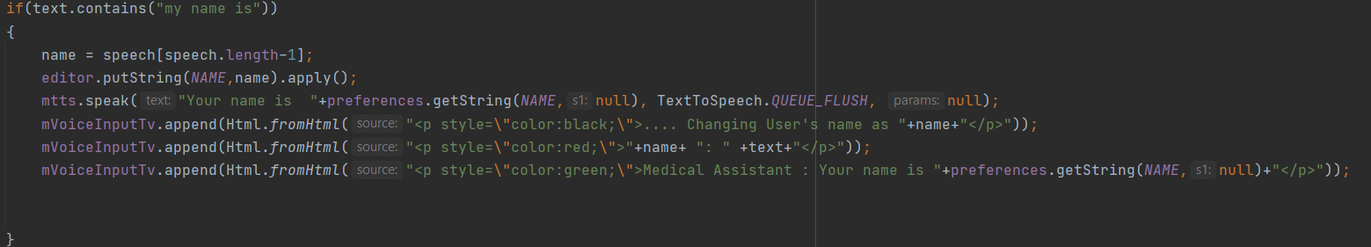

The below one is for not feeling good

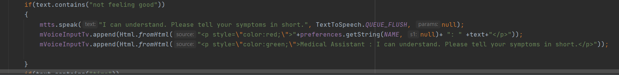

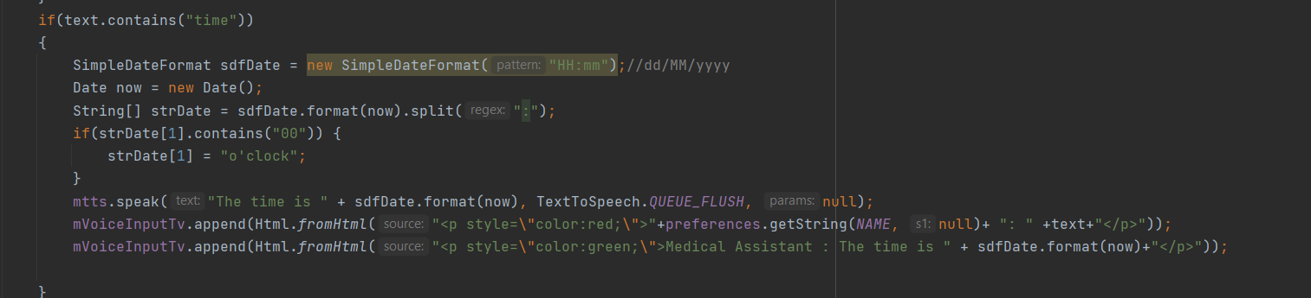





Output:

